Tristan Izlar

COP2360 C# Programming I

3/17/2021

# Card Identifier Application

1. Form:

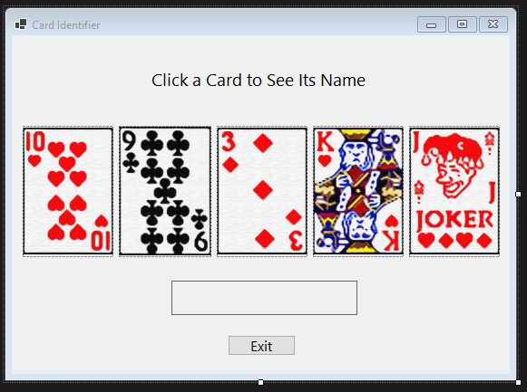

1. Starting State:

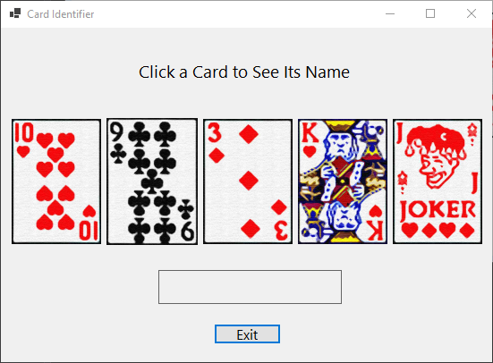

1. Selection State:

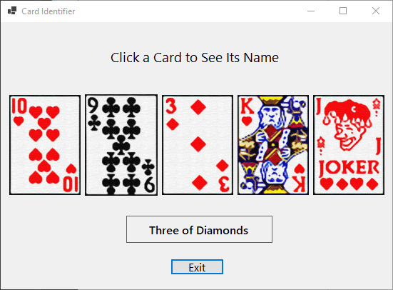

**Collaborators: I worked alone**